Given Data:

a Surface bounded by straight lines. It has two polygonal Openings. This can be considered as a general slab panel definition. Surface and Openings are defined as shown in the left table. A Surface can have any number of Openings and each Opening is made by number of straight lines.

A check needs to be performed to ensure that each Opening is completely inside the Surface and no two Openings intersect each other.

Solution:

I tried to show the given points are on the graph by using matplotlib module graph (scatter chart) shown below.

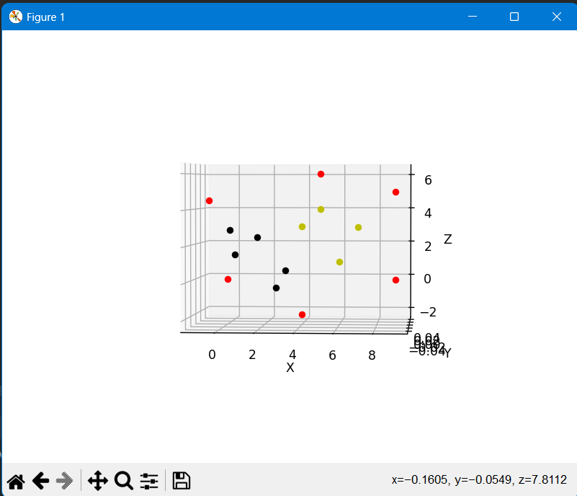

Based on the above graph I can say

**Red points:**

Red points are the outside boundary points – “1 to 6”.

**Black and yellow points:**

Based on the above graph I can say that the black and yellow color points are inside and also not overlapping each other.

The graph model code will prove that point “7 to 15” are inside the boundary.

Second code:

In the second code, I attempted to verify if the given points are located inside the given boundary by applying the following logic: "If the X coordinate of the point falls between the minimum and maximum X values of the boundary, AND the Z coordinate of the point falls between the minimum and maximum Z values of the boundary, then the point is considered to be inside the boundary."

**Equation:**

“x_minimum <= x <= x_maxinum and z_minimum <= z <= z_maximun”

Git link: https://github.com/paul47606/a-Surface-bounded-by-straight-lines.-It-has-two-polygonal-Openings.git